**https://blog.csdn.net/mao834099514/article/details/79094405**

**SQLServer空间查询geometry**

2018-01-18 11:54:25 [猫猫猫猫猫大人](https://me.csdn.net/mao834099514) 阅读数 5814更多

分类专栏： [SQL](https://blog.csdn.net/mao834099514/article/category/6035816) [ArcGis](https://blog.csdn.net/mao834099514/article/category/7408943)

版权声明：本文为博主原创文章，遵循 [CC 4.0 BY-SA](http://creativecommons.org/licenses/by-sa/4.0/" \t "_blank) 版权协议，转载请附上原文出处链接和本声明。

本文链接：<https://blog.csdn.net/mao834099514/article/details/79094405>

一、介绍

geometry数据类型为空间数据提供了一个存储结构，它是由任意平面上的坐标定义的。这种数据通常是用在区域匹配系统中的，例如由美国政府制定的州平面系统，或者是不需要考虑地球弯曲性的地图和内层布置图。

geometry 数据类型提供了与开放地理空间联盟(OGC)Simple Features Specification for SQL标准结合的属性和方法，使得你可以对geometry数据执行操作以产生行业标准的行为。

* 1
* 2
* 3

二、创建表和geometry字段以及插入点，线，多边形   
sql如下:

IF OBJECT\_ID ( 'dbo.SpatialTable', 'U' ) IS NOT NULL

DROP TABLE dbo.SpatialTable;

GO

CREATE TABLE SpatialTable

( id int IDENTITY (1,1),

geom geometry,

adress varchar );

GO

INSERT INTO SpatialTable (geom)

VALUES (geometry::STGeomFromText('POINT (20 180)', 4326));

INSERT INTO SpatialTable (geom)

VALUES (geometry::STGeomFromText('LINESTRING (100 100, 20 180, 180 180)', 4326));

INSERT INTO SpatialTable (geom)

VALUES (geometry::STGeomFromText('POLYGON ((0 0, 150 0, 150 150, 0 150, 0 0))', 4326));

GO

ps: 4326是空间引用标识符 (SRID) 一般写0或者4326

存入表中的geom字段如下:   
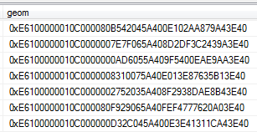

三、查询点线多边形包含关系

select \* from table1 a,table2 b where a.geom.STContains(b.geom)=1

注：除了包含关系还有很多，详查官方文档：   
<https://docs.microsoft.com/zh-cn/sql/t-sql/spatial-geometry/spatial-types-geometry-transact-sql>

四、(WKT)表示形式

geometry 列呈现为其开放地理空间联盟 (OGC) 熟知文本 (WKT)表示形式，并使用 STAsText() 方法。

* 1

查询到的geom字段格式如上图所示，为16进制特殊格式。想转成标准格式如下所示：SELECT @result.STAsText();

如下示例使用 STIntersection() 方法返回两个以前插入的 geometry 实例相交的点。

DECLARE @geom1 geometry;   
DECLARE @geom2 geometry;   
DECLARE @result geometry;

SELECT @geom1 = GeomCol1 FROM SpatialTable WHERE id = 1;   
SELECT @geom2 = GeomCol1 FROM SpatialTable WHERE id = 2;   
SELECT @result = @geom1.STIntersection(@geom2);   
SELECT @result.STAsText();

看个实例吧：   
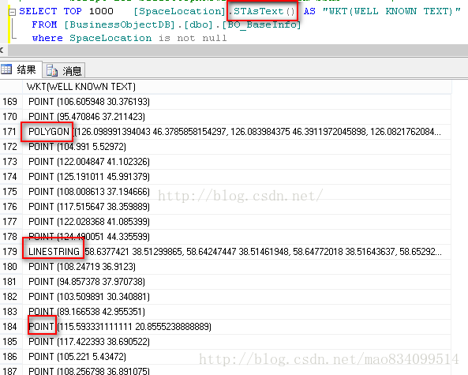

# 空间类型 - geometry (Transact-SQL)Spatial Types - geometry (Transact-SQL)

* 2017/03/14
  + [[](https://github.com/MicrosoftDocs/sql-docs.zh-cn/blob/live/docs/t-sql/spatial-geometry/spatial-types-geometry-transact-sql.md)](https://github.com/MicrosoftDocs/sql-docs.zh-cn/blob/live/docs/t-sql/spatial-geometry/spatial-types-geometry-transact-sql.md" \o "3 作者)
  + [[](https://github.com/MicrosoftDocs/sql-docs.zh-cn/blob/live/docs/t-sql/spatial-geometry/spatial-types-geometry-transact-sql.md)](https://github.com/MicrosoftDocs/sql-docs.zh-cn/blob/live/docs/t-sql/spatial-geometry/spatial-types-geometry-transact-sql.md" \o "3 作者)
  + [[](https://github.com/MicrosoftDocs/sql-docs.zh-cn/blob/live/docs/t-sql/spatial-geometry/spatial-types-geometry-transact-sql.md)](https://github.com/MicrosoftDocs/sql-docs.zh-cn/blob/live/docs/t-sql/spatial-geometry/spatial-types-geometry-transact-sql.md" \o "3 作者)

### 本文内容

1. [注册 geometry 类型](https://docs.microsoft.com/zh-cn/sql/t-sql/spatial-geometry/spatial-types-geometry-transact-sql?view=sql-server-ver15#registering-the-geometry-type)
2. [示例](https://docs.microsoft.com/zh-cn/sql/t-sql/spatial-geometry/spatial-types-geometry-transact-sql?view=sql-server-ver15#examples)
3. [另请参阅](https://docs.microsoft.com/zh-cn/sql/t-sql/spatial-geometry/spatial-types-geometry-transact-sql?view=sql-server-ver15#see-also)

适用对象：是SQL Server 是Azure SQL 数据库 否Azure Synapse Analytics (SQL DW) 否并行数据仓库**APPLIES TO:**yesSQL Server yesAzure SQL Database noAzure Synapse Analytics (SQL DW) noParallel Data Warehouse

平面空间数据类型 **geometry** 在 SQL ServerSQL Server 中作为公共语言运行时 (CLR) 数据类型实现。The planar spatial data type, **geometry**, is implemented as a common language runtime (CLR) data type in SQL ServerSQL Server. 此类型表示欧几里得（平面）坐标系中的数据。This type represents data in a Euclidean (flat) coordinate system.

SQL ServerSQL Server 支持 **geometry** 空间数据类型的一组方法。supports a set of methods for the **geometry** spatial data type. 这些方法包括开放地理空间信息联盟 (OGC) 标准和对该标准的一组 MicrosoftMicrosoft 扩展所定义的 **geometry** 方法。These methods include methods on **geometry** that are defined by the Open Geospatial Consortium (OGC) standard and a set of MicrosoftMicrosoft extensions to that standard.

geometry 方法的公差可高达 1.0e-7 \* extents。The error tolerance for the geometry methods can be as large as 1.0e-7 \* extents. extents 表示 **geometry** 对象的各点之间的近似最大距离。The extents refer to the approximate maximal distance between points of the **geometry**object.

## 注册 geometry 类型Registering the geometry Type

**geometry** 类型已进行预定义，可在每个数据库中使用。The **geometry** type is predefined and available in each database. 您可以创建 **geometry** 类型的表列并对 **geometry** 数据进行操作，就像使用其他 CLR 类型一样。You can create table columns of type **geometry** and operate on **geometry** data in the same manner as you would use other CLR types. 可以用在持久化和非持久化计算列中。Can be used in persisted and non-persisted computed columns.

## 示例Examples

### A.A. 显示如何添加和查询几何图形数据Showing how to add and query geometry data

以下两个示例显示了如何添加和查询几何图形数据。The following two examples show how to add and query geometry data. 第一个示例创建包含一个标识列和一个 geometry 列 GeomCol1 的表。The first example creates a table with an identity column and a geometry column, GeomCol1. 第三列将 geometry 列呈现为其开放地理空间信息联盟 (OGC) 熟知文本 (WKT) 表示形式，并使用 STAsText() 方法。A third column renders the geometry column into its Open Geospatial Consortium (OGC) Well-Known Text (WKT) representation, and uses the STAsText() method. 接下来将插入两行：一行包含 LineString 类型的 geometry实例，一行包含 Polygon 实例。Two rows are then inserted: one row contains a LineString instance of geometry, and one row contains a Polygon instance.

SQL复制

IF OBJECT\_ID ( 'dbo.SpatialTable', 'U' ) IS NOT NULL

DROP TABLE dbo.SpatialTable;

GO

CREATE TABLE SpatialTable

( id int IDENTITY (1,1),

GeomCol1 geometry,

GeomCol2 AS GeomCol1.STAsText() );

GO

INSERT INTO SpatialTable (GeomCol1)

VALUES (geometry::STGeomFromText('LINESTRING (100 100, 20 180, 180 180)', 0));

INSERT INTO SpatialTable (GeomCol1)

VALUES (geometry::STGeomFromText('POLYGON ((0 0, 150 0, 150 150, 0 150, 0 0))', 0));

GO

### B.B. 返回两个几何图形实例的交集Returning the intersection of two geometry instances

第二个示例使用 STIntersection() 方法返回此前插入的两个 geometry 实例相交的点。The second example uses the STIntersection() method to return the points where the two previously inserted geometry instances intersect.

SQL复制

DECLARE @geom1 geometry;

DECLARE @geom2 geometry;

DECLARE @result geometry;

SELECT @geom1 = GeomCol1 FROM SpatialTable WHERE id = 1;

SELECT @geom2 = GeomCol1 FROM SpatialTable WHERE id = 2;

SELECT @result = @geom1.STIntersection(@geom2);

SELECT @result.STAsText();

### C.C. 在计算列中使用几何图形数据Using geometry in a computed column

以下示例使用 **geometry** 类型创建具有持久化计算列的表。The following example creates a table with a persisted computed column using a **geometry** type.

SQL复制

IF OBJECT\_ID ( 'dbo.SpatialTable', 'U' ) IS NOT NULL

DROP TABLE dbo.SpatialTable;

GO

CREATE TABLE SpatialTable

(

locationId int IDENTITY(1,1),

location geometry,

deliveryArea as location.STBuffer(10) persisted

)